Project Title

- Features

- 128K × 8 bit CMOS Static RAM [Cypress Semiconductors- CY7C1019CV33]
- Key Features : Automatic power-down when deselected
- Address width : 17 bit (A0-A16)
- Data width : 8 bit (IO0-IO7)
- Operating Voltage : 1V ± 10%
- Operating Temperature : Commercial (0 - 70°C)
- Technology Node : UMC 90nm
- Cycle time : 15 ns (min)
- Address to Data Valid time : 15ns (max)

- Background information

2.1 PROCESS TECHNOLOGY
UMC 90nm technology node has been used to design the SRAM. The minimum transistor has 80 nm length and 120 nm width. Low Vt transistors N_10_SPLVT and P_10_SPLVT are used to get a high speed operation but it also reduces the static noise margins of the cell.

2.1.1 DEVICE MODEL :

Threshold voltage of NMOS: | 0.23 V
Threshold voltage of PMOS: | -0.19 V
Gate capacitance of Minimum sized NMOS: |  | 0.491 fF (approx.)
Gate capacitance of Minimum sized PMOS: |  | 0.247 fF (approx.)

2.1.2 SPICE CONTROL PARAMETERS :

Relative Tolerance (reltol): 1e-3

VAbsolute Tolerance (V abstol): 1e-6 V

IAbsolute Tolerance (Iabstol): 1e-6 V

Give a flow diagram of the design flow used by you, from floor plan to final layout. Describe the division of labour and project planning.

2.2 DESIGN FLOW DIAGRAM :

2.3 PROJECT PLANNING AND DIVISION OF DESIGN TASKS (GANTT CHART ):

2.4 LITERATURE SURVEY :

[1] Neil H.E. Weste ,David Harris , “CMOS VLSI Design : A Circuits and Systems Perspective”,Prentice Hall

[2] E. Seevinck, F. List, J. Lohstroh, “Static-Noise Margin Analysis of MOS SRAM Cells” JSSC, Oct ‘87.

[3] R. Jacob Baker , “CMOS :Circuit Design ,Layout and Simulation”,Wiley

[4] Betty Prince, “Semiconductor Memories : A Handbook of Design Manufacture and Applications”,Wiley

[5] Christieensen D.C. Arandilla, Anastacia B Alvarez, “Static Noise Margin of 6T SRAM cell in 90 nm CMOS ” 2011 UKSim 13th International Conference on Modelling and Simulation.

[6] J.M.Rabaey, A.Chandrakasan, B.Nikolic, “Digital Integrated Circuits: A Design Perspective”,Prentice Hall

2.5 SIMULATION TOOLS LIST :

Schematic Editor - Cadence Design Tool Kit - Schematic Editor

Layout Editor - Cadence Design Tool Kit - Virtuoso

Design Rule Checker – Mentor Graphics Calibre LVS

Layout vs Schematic tool – Mentor Graphics Calibre LVS

Parasitic Extraction – Mentor Graphics Calibre PEX

- Architecture

  - Array Partitioning
Describe the core partitioning strategy i.e. no. of planes, blocks, sub-blocks with justifications with reference to specs. Describe how each entity is selected (i.e. which address bits) and what happens to those which are not selected. Give diagrams of the partitioning.

  - Floor Plan
Draw and explain your floor plan. Show the locations of i/o pad and buffers, ATD, decoders, sense amplifiers, column pre-charge, column muxes, write drivers etc. Justify these choices.

Show the main global lines / buses.

An example is given below

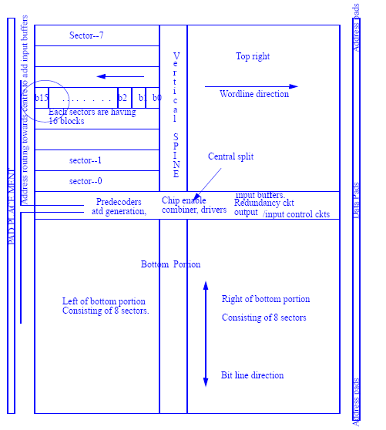

- DETAILED DESIGN
  - CELL AND CORE DESIGN
    - CELL TYPE

Static 6-T cell is chosen for SRAM cell design. This topology has the following advantages over 8T or 9T SRAM cell.

- Lower power dissipation - 6T SRAM cell has less leakage current because less number of transistors are being used compared to 7T, 8T, and 9T SRAM cell architecture.

- Good stability - 6T SRAM cell has good stability as compared to 4T SRAM cell. As 4T SRAM cell has lower value of SNM (Static Noise Margin) in low voltage operation.

- Relaxed area constraints.

- Symmetric structure - Helps during fabrication of device.

    - CELL SCHEMATIC 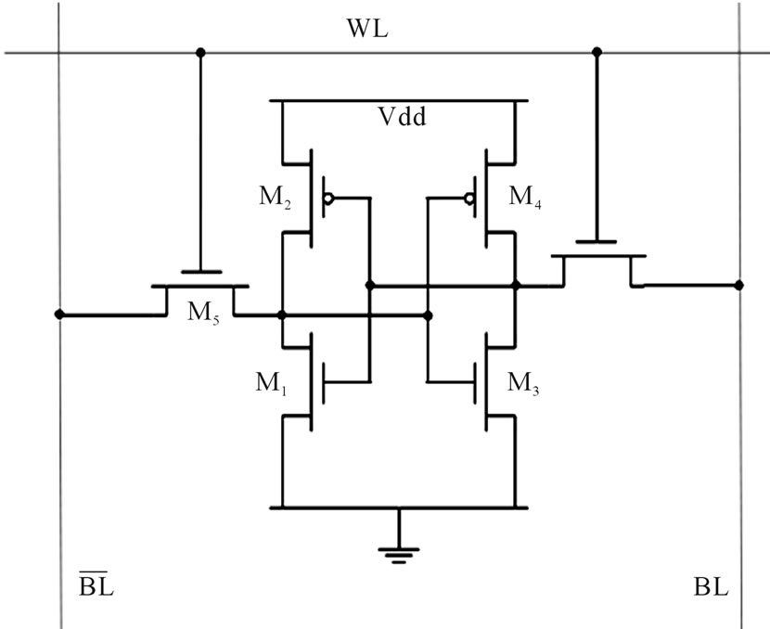

M₁ M₃ : Pull down transistors.
M₂ M₄ : Pull up transistors.
M₅ M₆ : Access transistors

For Read Stability : M1,M3 pull down transistors should be stronger than the M5,M6 access transistors.

For Write Stability : M2,M4 pull up transistors should be weaker than the M5,M6 access transistors.

SRAM Cell Sizing:

The access transistors were chosen to be of minimum size so as to minimize the bitline capacitance.

Considering acceptable noise margins pull-up ratio was chosen to be 1 and cell ratio was 3.

- Optimum CR = 3 & PR = 1.0
- Sizing of Transistors : L= 80 nm
- Pull-up Transistors : W = 120 nm
- Access Transistors : W = 120 nm
- Drive Transistors : W = 360 nm
- Process Corner : Slow NMOS Slow PMOS (ss)

    - CELL SCHEMATIC SIMULATIONS

      - STATIC NOISE MARGIN

The static noise margin (SNM) measures how much noise can be applied to the inputs of the two cross-coupled inverters before a stable state is lost (during hold or read) or a second stable state is created (during write).
Acceptable value of SNM are used to decide the optimum values of CR, PR.
Cadence Virtuoso was used for circuit simulation and the corresponding Butterfly curves were plotted using MATLAB.

      - READ STATIC NOISE MARGIN
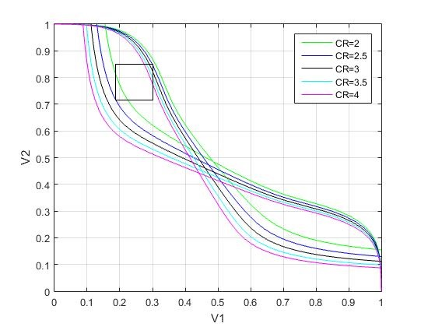

Read Static Noise Margin (CR = 3) = 184 mV

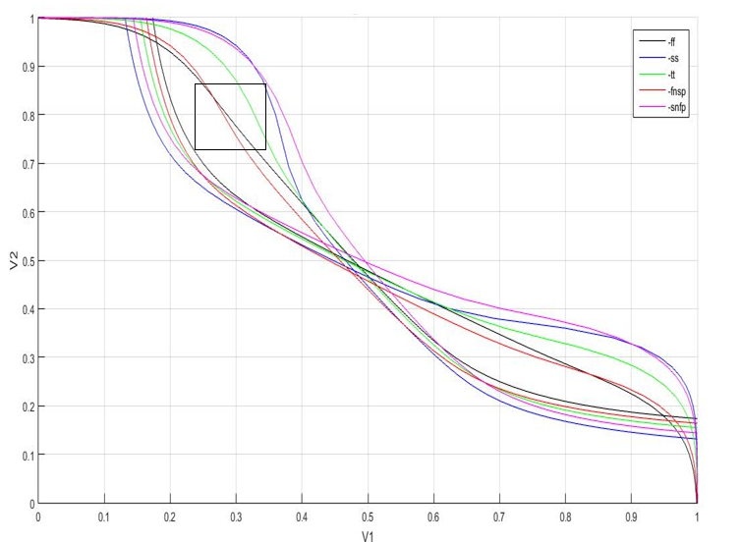

Read Static Noise Margin (with process variations, worst case) = 163 mV

      - WRITE MARGIN

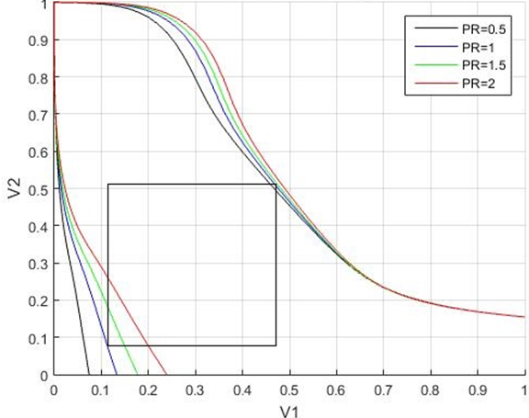

Write Static Noise Margin (PR = 1) = 523 mV

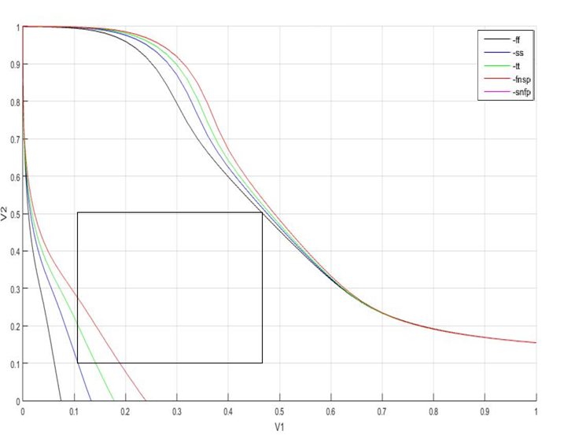
Write Static Noise Margin (with process variations, worst case)= 509 mV

      - HOLD NOISE MARGIN

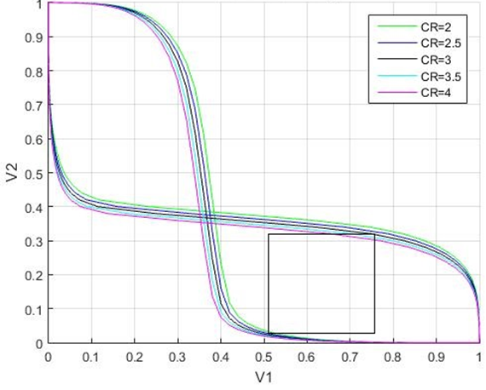
Hold Static Noise Margin (CR = 3) = 387mV

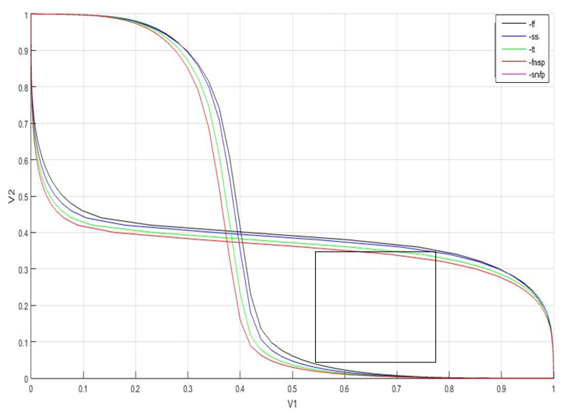
Hold Static Noise Margin (with process variations , worst case) = 353mV

      - TRANSIENT SIMULATION :
Single Memory Cell Simulation : Signals from top to bottom are in sequence : Wordline , Precharge , Sense Enable , Bitline , Bitline_Bar Out(data stored in the cell).

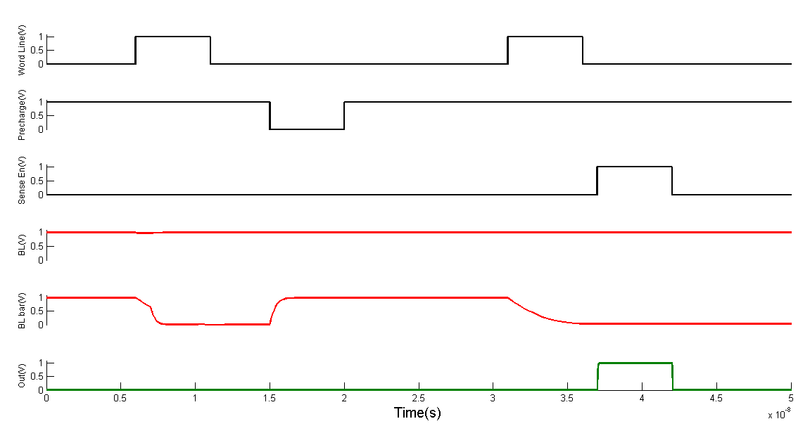

    - CELL LAYOUT

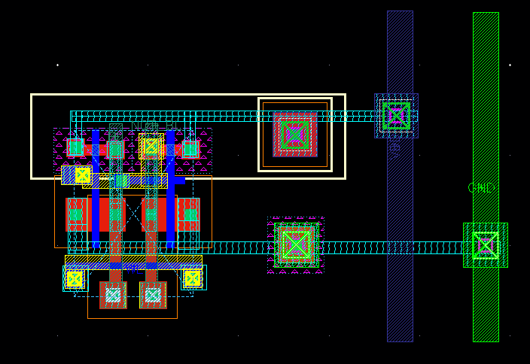

6T Cell Properties :

Parameter | Value
Length (um) | 2.105
Width (um) | 1.74
Area (sq. um) | 3.67

At the top, the VDD contacts are shared with transistor above and the adjacent column transistors. The ground contacts are also shared between the adjacent column transistors. Also, at the bottom the contacts for BIT and BIT_B are shared with the transistor below.

Bitline Twisting Scheme :

- Bit line twisting will make sure that effect of coupling noise will be symmetric on both BL and BL_BAR, and thus effect of coupling noise will be reduced.
- Bit line twisting scheme, where bit line is twisted after every 16 columns (or after every 16th Word Line).
- There are total 512 columns. Bit line is twisted 32 times in each core.
- Metal Layer 4 is used for twisting one of the bit lines.

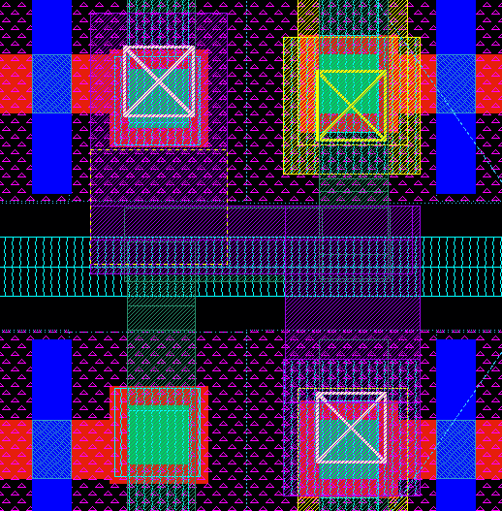
    - SUMMARY OF CELL :

Parameter | Value
Cell Length (um) | 2.105
Cell Width (um) | 1.741
Cell Area (sq. um) | 3.67
Estimated Core Area (sq.um) | 3848273.92
Read SNM (mV) | 0.184
Write SNM (mV) | 0.523

    - CORE LAYOUT

      - CORE ASSEMBLY

Optimized 4x4 Memory Block :

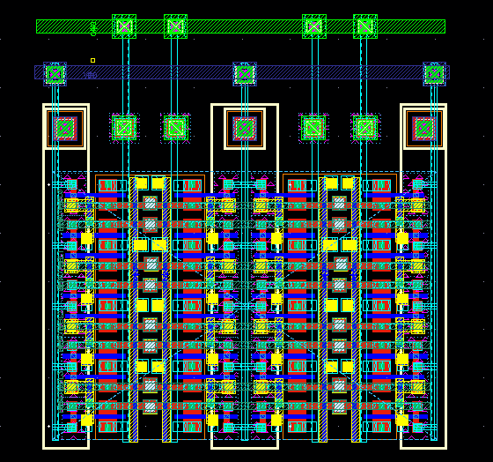

4x4 Memory Block Properties :

Parameter | Value
Length (um) | 7.77
Width (um) | 5.54
Area (sq. um) | 43.04
Area/cell (sq. um) | 2.69

256x512 Memory Bank :

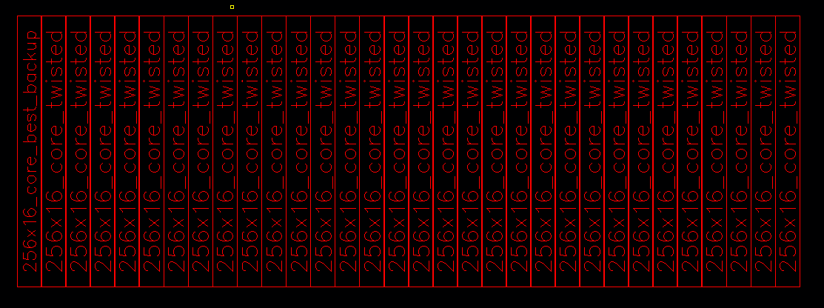

256x512 Memory Bank Properties :

Parameter | Value
Length (um) | 1066
Width (um) | 368
Bank Area (sq. um) | 392288
Core Area (sq. um) | 3138304
Area/cell (sq. um) | 3.01

      - CORE PARASITICS

- Capacitance Calculations :

For BL we planned to use Metal 3.
Metal 3 Parasitic extractions : R = 0.727 Ω/μm , C = 62.43 aF/ μm.

Cbitline (Bitline Capacitance)
= No. of cells in a row x Length of cell x Capacitance of metal 3 + Total junction capacitance of access transistors

=512 x 2μm. x 62.43 aF/μm. + (115aF x 512)

=122.808 fF

- Resistance Calculations :

Rbitline (Bitline Resistance)

= No. of cells in a row x Length of cell x Resistance of metal 3 =512 x 2μm. x 0.727 Ohm/μm.

=744.448 fF

  - IO pads, buffers and drivers.
    - Descriptions Input / Output / I/O pads
    - Layouts (if available)
    - Physical and Electrical Characteristics
      - Dimensions and pitch
      - ESD limits
      - Capacitances and other parasitics
        - Give Estimated / Actual Values
      - Simulation
        - Simulation of extracted views
Simulation of drivers must be done with proper parasitics and loads. Use the load specified in ac specs.

  - ATD scheme
    - ATD inputs
List the inputs used and their source in a table

    - ATD outputs
List the outputs and their destination in a table.
      - Estimated load capacitances on outputs

    - ATD Pulse width
ATD pulse with calculation with justification

    - ATD circuitry used with schematic
Give bulleted explanation of circuit operation. Cite any references of ideas you have used from literature..

    - ATD circuit schematic simulation
Give simulation graph with proper annotation. Give the signals proper names and show the relationships between them with arrows. Do not forget to add load capacitances.

    - ATD circuit layout
Give layout picture. State whether circuit meets any pitch restrictions. Give circuit dimensions and area. State whether layout passed DRC and LVS.

    - ATD circuit extracted simulation
Give simulation report (not graph) in terms of worst and best corner timing. Do not forget to add load capacitances.

  - Decoding scheme
    - Row Decoding
      - Scheme used
Flat or hierarchical. Describe with block diagrams. Describe logic type used.
      - Inputs used
List the inputs used and their source in a table.
      - Outputs produced and their routing
List the outputs and their destination in a table.

        - Estimated load capacitance on outputs

      - Row decode circuitry with schematic
Give bulleted explanation of circuit operation. Cite any references of ideas you have used from literature..

      - Row decode circuit schematic simulation
Give simulation graph with proper annotation. Give the signals proper names and show the relationships between them with arrows.
First give simulation of individual levels and then of entire decode path. Do not forget to add load capacitances.

      - Row decode circuit layout
Give layout picture. State whether circuit meets any pitch restrictions. Give circuit dimensions and area. State whether layout passed DRC and LVS.

      - Row decode circuit extracted simulation
Give simulation report entire extracted decode path (not graph) in terms of worst and best corner timing. Do not forget to add load capacitances.

    - Column Decoding
      - Scheme used
Flat or hierarchical. Describe with block diagrams. Describe logic type used. Include the column muxes.

      - Inputs used
List the inputs used and their source in a table.

      - Outputs produced and their routing
List the outputs and their destination in a table.

        - Estimated load capacitance on outputs

      - Column decode circuitry with schematic
Give bulleted explanation of circuit operation. Cite any references of ideas you have used from literature..

      - Column decode circuit schematic simulation
Give simulation graph with proper annotation. Give the signals proper names and show the relationships between them with arrows.
First give simulation of individual levels and then of entire decode path. Do not forget to add load capacitances.

      - Column decode circuit layout
Give layout picture. State whether circuit meets any pitch restrictions. Give circuit dimensions and area. State whether layout passed DRC and LVS.
Give simulation report entire extracted decode path (not graph) in terms of worst and best corner timing.

      - Column decode circuit extracted simulation
Give simulation report entire extracted decode path (not graph) in terms of worst and best corner timing. Do not forget to add load capacitances.

  - Core I/O
    - Precharge Circuitry
      - Scheme used
      - Inputs used
List the inputs used and their source in a table.

      - Outputs produced and their routing
List the outputs and their destination in a table.

        - Estimated load capacitance on outputs

      - Precharge circuitry with schematic
Give bulleted explanation of circuit operation. Cite any references of ideas you have used from literature..

      - Precharge circuit schematic simulation
Give simulation graph with proper annotation. Give the signals proper names and show the relationships between them with arrows. Do not forget to add load capacitances.

      - Precharge circuit layout
Give layout picture. State whether circuit meets any pitch restrictions. Give circuit dimensions and area. State whether layout passed DRC and LVS.
Give simulation report entire extracted decode path (not graph) in terms of worst and best corner timing.

      - Precharge circuit extracted simulation
Give simulation report entire extracted decode path (not graph) in terms of worst and best corner timing. Do not forget to add load capacitances

    - Sense amplifiers
      - Scheme used
Single or hierarchical. Describe with block diagrams. Describe signal levels at various points.

      - Inputs used
List the inputs used and their source in a table.

      - Outputs produced and their routing
List the outputs and their destination in a table.

        - Estimated load capacitance on outputs

      - Sense Amplifier circuitry with schematic
Give bulleted explanation of circuit operation. Cite any references of ideas you have used from literature.

      - Sense Amplifier circuit schematic simulation
Give simulation graph with proper annotation. Give the signals proper names and show the relationships between them with arrows. Do not forget to add load capacitances.

      - Sense Amplifier circuit layout
Give layout picture. State whether circuit meets any pitch restrictions. Give circuit dimensions and area. State whether layout passed DRC and LVS.
Give simulation report entire extracted decode path (not graph) in terms of worst and best corner timing.

      - Sense Amplifier circuit extracted simulation
Give simulation report entire extracted decode path (not graph) in terms of worst and best corner timing. Do not forget to add load capacitances.

    - Write Drivers
      - Scheme used
      - Inputs used
List the inputs used and their source in a table.

      - Outputs produced and their routing
List the outputs and their destination in a table.

        - Estimated load capacitance on outputs

      - Write Driver circuitry with schematic
Give bulleted explanation of circuit operation. Cite any references of ideas you have used from literature..

      - Write Driver circuit schematic simulation
Give simulation graph with proper annotation. Give the signals proper names and show the relationships between them with arrows. Do not forget to add load capacitances.

      - Write Driver circuit layout
Give layout picture. State whether circuit meets any pitch restrictions. Give circuit dimensions and area. State whether layout passed DRC and LVS.
Give simulation report entire extracted decode path (not graph) in terms of worst and best corner timing.

Write Driver circuit extracted simulation

Give simulation report entire extracted decode path (not graph) in terms of worst and best corner timing. Do not forget to add load capacitances.

  - Any other components used
    - Justification for use
      - Describe Merits and overheads
    - Scheme used
    - Inputs used
    - Outputs produced and their routing
      - Estimated Load on outputs
    - Component Circuitry with schematic
    - Component circuit schematic simulation
    - Component circuit layout
    - Component circuit extracted simulation

- Integration
  - Critical Path simulation
    - Critical Path schematic
Give critical path schematic with proper routing load capacitances at all points. Use full data width (x8/ x4/ x16). You should be able to see data being written to and read from selected core cells. Use the worst case block in terms of routing delays.
    - Critical Path Simulation
Use extracted views of all modules. Use proper wire capacitances for global lines.
      - Stimuli used
List the stimuli used and their rise times.
      - Results obtained
Use simulation graphs to obtain the timings / power etc. asked for in the specs. List in a table the spec value and the obtained value for worst, best and typical corner cases. Do not be afraid to report values that don’t meet specs since God will not strike you with lightning if you do not meet specs.
        - Critical path characteristics
Report the following delays in a table:
Address i/p from pad to core,
ATD Pulse Width
Address to Row Predecoder O/p
Row Predecoder to Next decoder, and so on till Global wordline
Global wordline to local wordline
Address to Col Predecoder O/p (if applicable)
Row Predecoder to Next decoder, and so on till col select
Column Sense amp enable to databus
Data bus to Data out (pad drivers and pad loads included)
Report the power consumption in
Address buffers
Pad drivers
Sense Amplifiers
Write drivers
ATD
Decoders

    - Full chip layout integration
      - Layout view
Give a picture of full chip layout.
Give salient points from full chip DRC and LVS reports. DON’T FORGET VDD and GROUND ROUTING
Examine the different layers of the full chip layout to see if there are any irregularities or kinks which may lead to hot spots.
      - Area report
Report the total area consumed in
I/O pads
Address buffers
Pad drivers
Sense Amplifiers
Write drivers
ATD
Decoders
Global Routing
TOTAL AREA
CORE EFFICIENCY

LIST OF REFERENCES

.

.

